# CS 255 System Design Document Template

## UML Diagrams

### UML Use Case Diagram

### UML Activity Diagram 1: Customer Registration

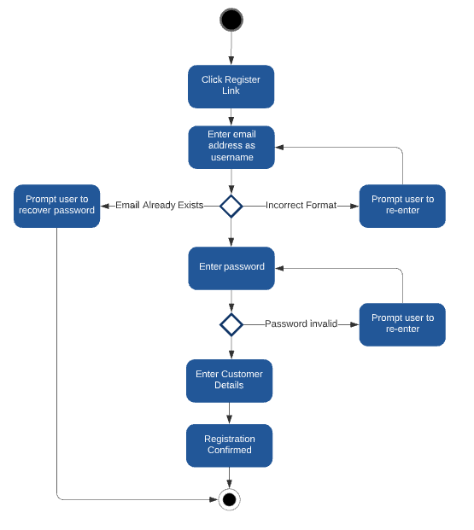

### UML Activity Diagram 2: Edit Profile

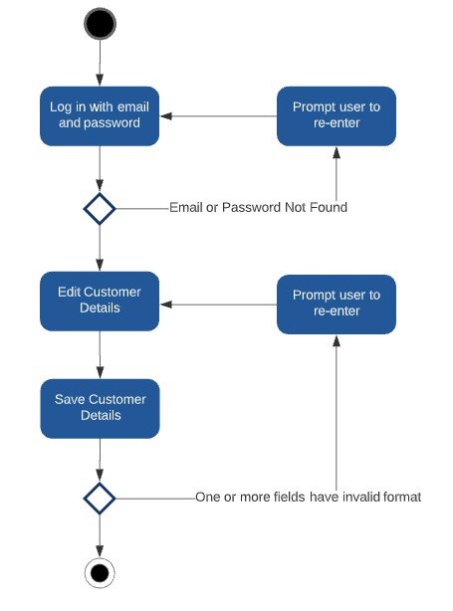

### UML Sequence Diagram: Edit Profile

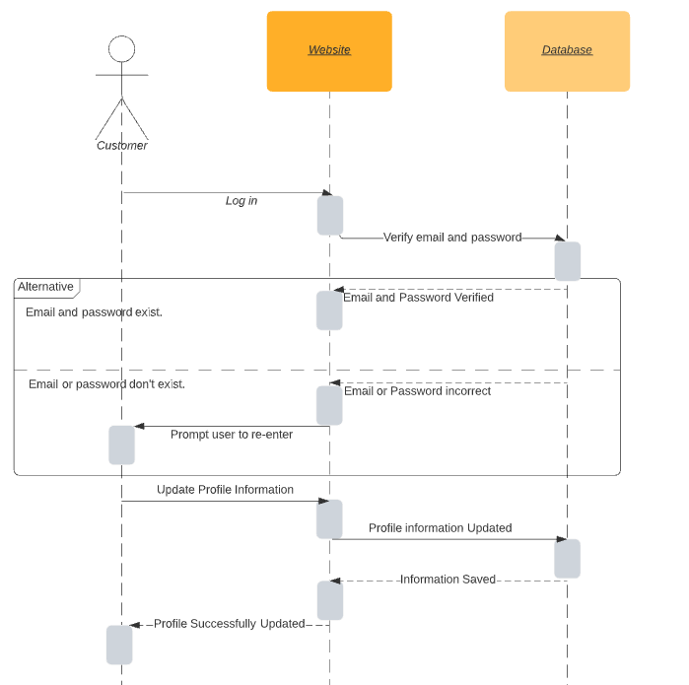

### UML Class Diagram

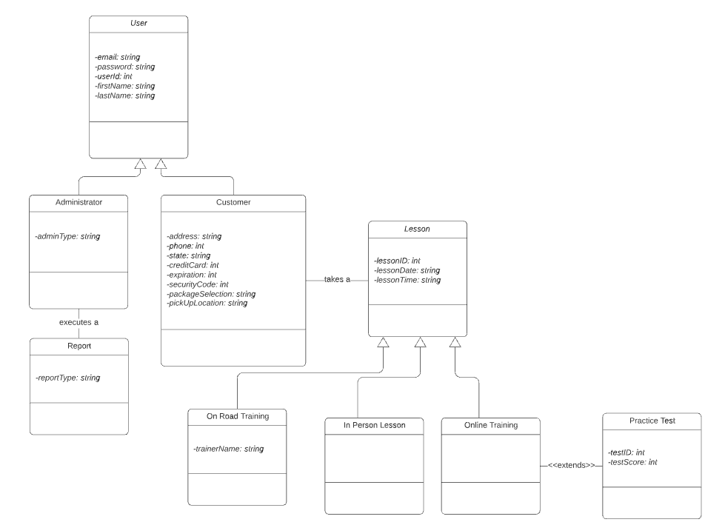

## Technical Requirements

* Platform
  + The application shall be hosted in the cloud via Amazon Web Services (AWS).
  + AWS will make infrastructure updates automatically every Saturday at 2am. This configured day/time can be changed as needed.
  + Because it is a cloud-based solution, the application will run on any platform that connect to the internet utilizing a recent version of one of the following browsers:
    - Google Chrome
    - Mozilla Firefox
    - Microsoft Edge
* Database
  + The system shall use the AWS DynamoDB service to store all data necessary.
* Security
  + Each user shall be identified with a numeric UserID within a table within AWS DynamoDB.
  + The AWS CloudWatch service shall be utilized to monitor and alert the IT Administrator of any system problems.
  + The connection shall be secured via https.
  + The application shall lock all user accounts in the event that it detects a “brute force” hacking attempt. At this point only and administrative user may log in, and unlock user accounts, once the hacking attempt has been mitigated.
  + The IT administrator will have root access to the AWS platform. This will enable them to make changes to the application code as well as the data behind it.
  + The IT administrator will be able to add/remove/modify users directly in the User table within DynamoDB, in case this is necessary.
* Maintenance
  + Platform updates will be automated, and any application issues resulting from such updates will be detected by the AWS CloudWatch service, and such notifications will be sent to the IT Administrator.
  + The system shall be connected via API to the DMV. When the DMV makes updates to their rules, policies, or sample questions, the IT administrator shall be emailed automatically. When that occurs, management will determine any necessary steps (if any) required to alter the training and online practice tests.
  + The AWS Backup service will be integrated to perform automated backups of the data in DynamoDB.